The goal is to estimate features of the target distribution F. The reliability of such estimates depends on the extent to which sample averages computed using realizations of the chain correspond to their expectation under the limiting stationary distribution of the chain.
Has the chain run long enough? Has the chain traversed all portions of the region of support of F?
Ensuring Good Mixing and Convergence Monitoring
The problem of deciding when to stop the chain is an important one. After all, the main purpose of using MC is to get a sample from the target function and explore its
characteristics. If the resulting sequence has not converged to the target, then the estimates and inferences we get from it are suspect. Most of the methods that have been proposed in the literature are really diagnostic in nature and have the goal of monitoring convergence.
Gelman and Rubin Method
We will use to represent the characteristic of the target distribution (mean, moments, quantiles, etc.) in which we are interested. One obvious way to monitor convergence to the target distribution is to run multiple sequences of the chain and plot versus the iteration number. If they do not converge to approximately the same value, then there is a problem.
The method is based on the idea that the variance within a single chain will be less than the variance in the combined sequences, if convergence has not taken place. The Gelman-Rubin approach monitors the scalar quantities of interest in the analysis (i.e., v).
We start off with k parallel sequences of length n (samples) starting from over dispersed points in the target distribution. The between-sequence variance B and the within-sequence W are calculated for each scalar summary v.
We denote the j-th scalar summary in the i-th chain by
$v_{ij}; i=1,…,k, j=1,…,n$. (1)
Thus, the subscript j represents the position in the chain or sequence, and i
denotes which sequence it was calculated from.
The between-sequence variance B is given as
$B=\frac{n}{k-1}\sum_{i=1}^{k}{{( \overline{v_{i.}}-\overline{v_{..}})}^{2}},$ (2)
where $\overline{v_{i.}}=\frac{1}{n}\sum_{j=1}^{n}{v_{ij},}$ (3)
and $\overline{v_{..}}=\frac{1}{k}\sum_{i=1}^{k}{ \overline{v_{i.}},}$ (4)
Equation (3) is the mean of the n values of the scalar summary in the ith sequence, and Equation (4) is the average across sequences.
The within-sequence variance W is determined by
$W=\frac{1}{k}\sum_{i=1}^{k}{{S_{i}}^{2}},$ (5)
with ${S_{i}}^{2}=\frac{1}{n-1}\sum_{j=1}^{n}{{(v_{ij}-{\overline{v}}_{i.})}^{2}},$ (6)
Note that Equation (6) is the sample variance of the scalar summary for the ith sequence, and Equation (5) is the average variance for the k sequences.
Finally, W and B are combined to get an overall estimate of the variance of v in the target distribution: $\hat{var(v)}=\frac{n-1}{n}W+\frac{1}{n}B,$ (7)
Equation (7) is a conservative estimate of the variance of v, if the starting points are over-dispersed [Gelman, 1996]. In other words, it tends to over estimate the variance.
Alternatively, the within-sequence variance given by W is an underestimate of the variance of v. This should make sense considering the fact that finite sequences have not had a chance to travel all of the target distribution resulting in less variability for v. As n get large, both $\hat{var(v)}$ and W approach the true variance of v, one from above and one from below.
The Gelman-Rubin approach diagnoses convergence by calculating
$\sqrt{\hat{R}}=\sqrt{\frac{\hat{var(v)}}{W}},$ (8)
This is the ratio between the upper bound on the standard deviation of and the lower bound. It estimates the factor by which might be reduced by further iterations.
The factor given by Equation (8) is called the estimated potential scale reduction. If the potential scale reduction is high, then the analyst is advised to run the chains for more iterations. Gelman [1996] recommends that the sequences be run until for all scalar summaries are less than 1.1 or 1.2.
A toy example
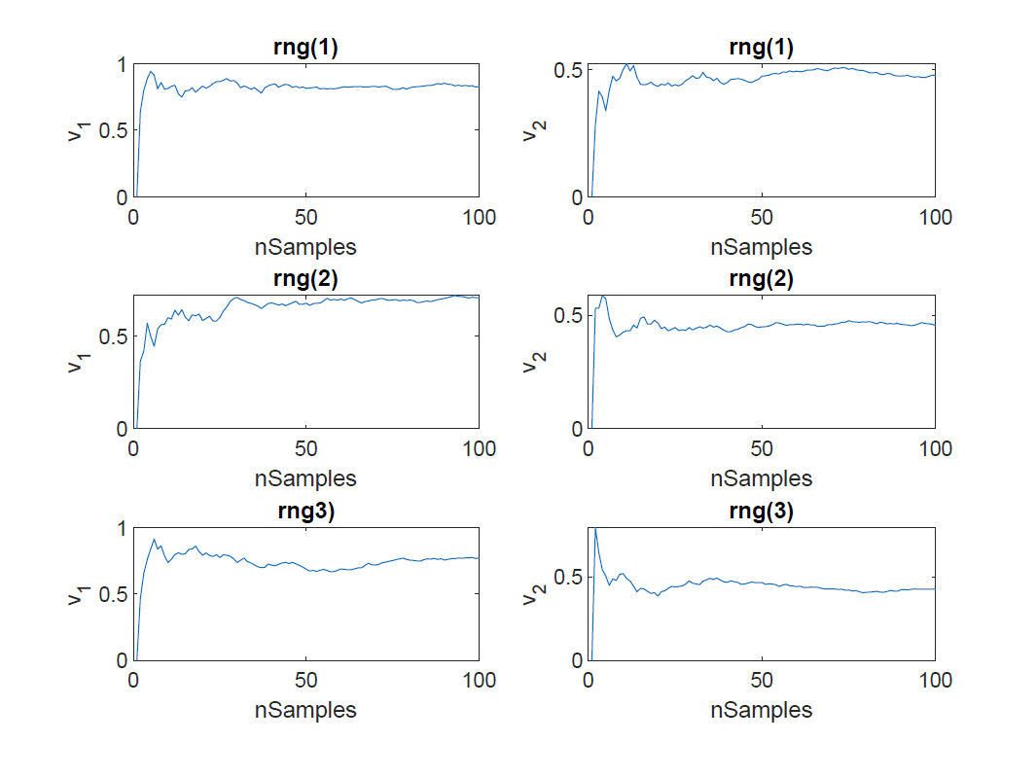
- S_Grid=1000
S_Grid =100

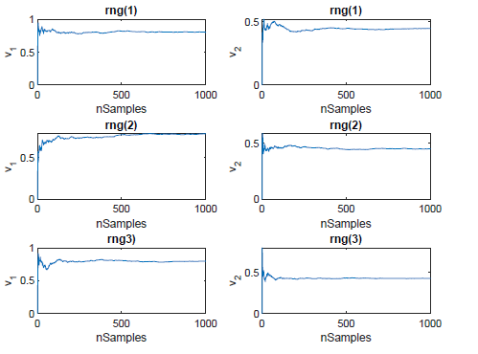

S_Grid=10

S_Grid=5
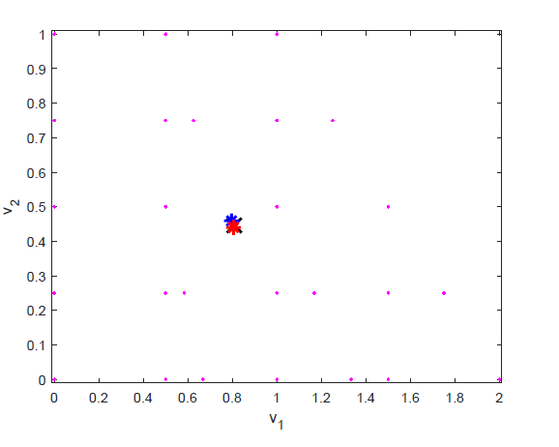
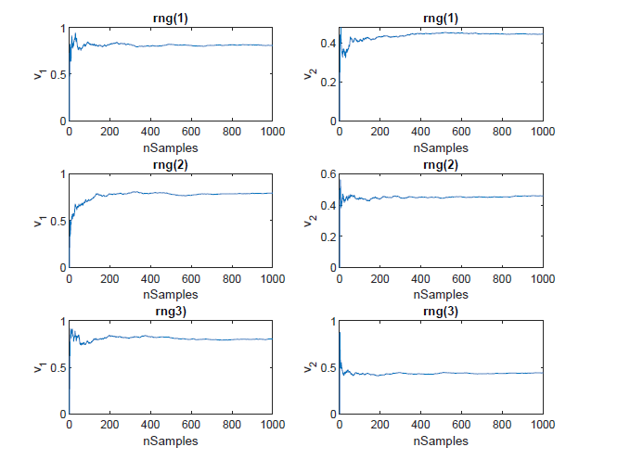

b. Grid number=2

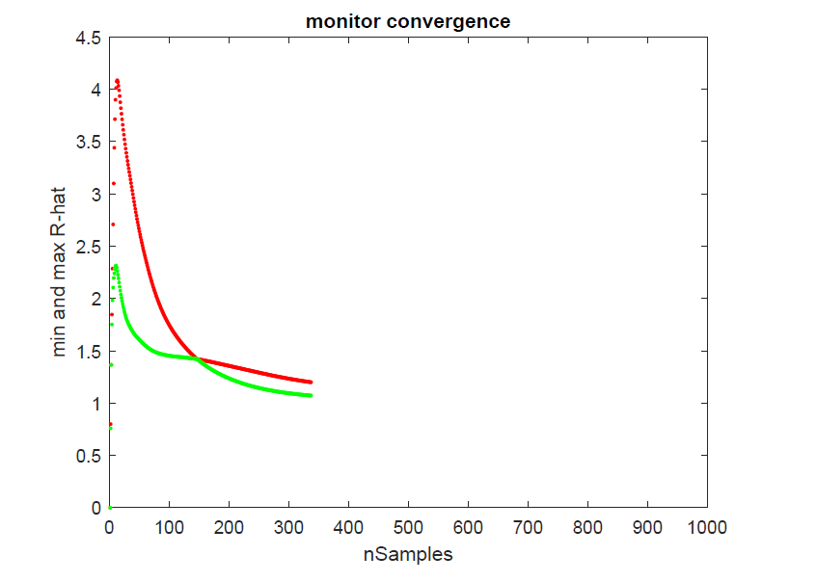

The method suggests that the chain has approximately converged but it might have not actually.
Solution: 1) increase seeds/initialization; 2) a variety of diagnostic techniques would be used.

A real example: E.Coli
- nGrid=20
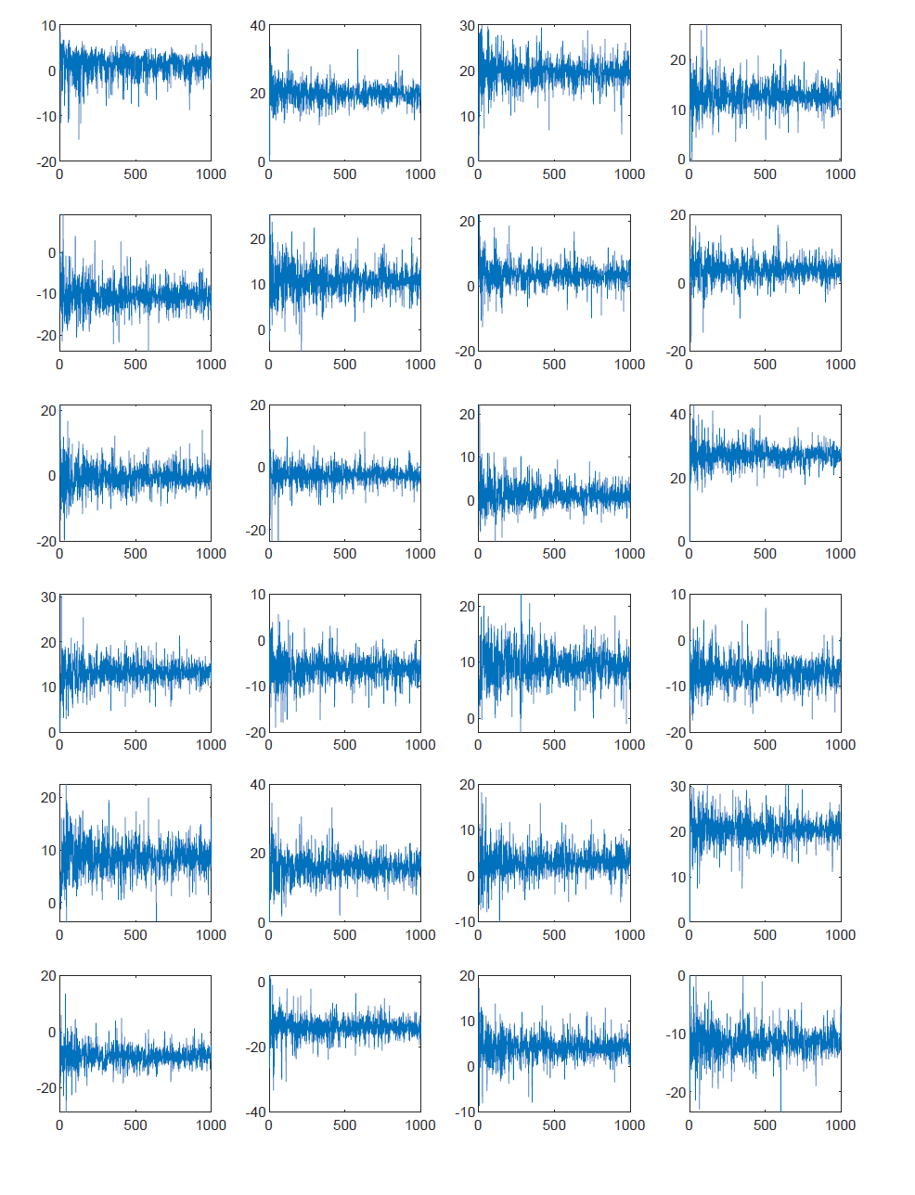
b. nGrid=5

The evidence we have at the moment is not sufficient to support any firm conclusion.
We can not find the link here and now, but it does not mean that it is not there.
(Ongoing)
Q 1. Variance-covariance matrix of the target distribution (chains of flux mean values).
Most underdetermined problems (flux distributions) are inherently multivariate in that the goal is to sample from a multidimensional target distribution. Acknowledging the multivariate nature of estimation is critical in order to account for the interdependence??? between components of the chain (Vatset al., 2019). Brooks and Gelman (1998) proposed the following multivariate extension of the univariate GR diagnostic.
(Dai and Jones 2017, Kosorok 2000, Liu and Flegal 2018, Vats and Flegal 2018, and Vats et al. 2018)).

Q 2.

The slow convergence of the algorithm is a notable drawback. How to “accelerate” convergence?

Like the approach of a low-discrepancy sequence (https://en.wikipedia.org/wiki/Low-discrepancy_sequence), is there any idea of providing alternative estimator of the same quantity in our case?

Q 3.

How estimate confidence bands of mean value, and how they change over different S_Grids?
Is it linked with discretization percentage of samples whose sum of weights represents 99.9% of the total sum of weights???(used in the paper)
The appeal of using a bootstrapped confidence band is somehow limited because of the computing cost? In more complex settings, producing a new sequence may prove much more costly than resampling (bootstrapping) from the original sequence???

Rao-Blackwellization/deconditioning: One can reduce the variance of an unbiased estimator by conditioning it on the sufficient statistics.

Q 4. (NOT considering it anymore)

How to “control(reduce)” the variance of marginal distributions for each flux? Maybe not very necessary for metabolic flux analysis anymore as we know the marginal distributions??
Rao-Blackwellization/deconditioning: One can reduce the variance of an unbiased estimator by conditioning it on the sufficient statistics.

References
- Gelman, A. and D. B. Rubin. 1992. “Inference from iterative simulation using multiple sequences (with discussion),” Statistical Science, 7:457–511.
- Dootika Vats, Christina Knudson, “Revisiting the Gelman-Rubin Diagnostic” .arXiv:1812.09384v2 [stat.CO] 13 Apr 2020.

Convergence diagnostics
The problem of deciding when to stop the chain/simulation is an important one. The method of Gelman and Rubin [1992] is one of the simplest to understand and to implement.
If A is an m*n nonrandom matrix and b is an n*1 nonrandom vector, then Var(Ay+b)=A[Var(y)]A’.
$f_{X}(x)=\frac{1}{(α_{x})}x^{α_{x}-1}e^{-{}_{x}x}{{}_{x}}^{α_{x}}$.

var(v_mean)= Z*var(q_mean)*Z’;

Gelman [1996] points out that lack of convergence can be detected by comparing multiple sequences, but cannot be detected by looking at a single sequence.
The Gelman-Rubin convergence diagnostic is based on running multiple chains. Cowles and Carlin [1996] recommend ten or more chains if the target distribution is unimodal. The starting points for these chains are chosen to be widely dispersed in the target distribution. This is important for two reasons.
First, it will increase the likelihood that most regions of the target distribution
are visited in the simulation. Additionally, any convergence problems are
more likely to appear with over-dispersed starting points.

We will discuss in detail one method due to Gelman and Rubin [1992] and Gelman [1996] because it is one of the simplest to understand and to implement. We also very briefly describe another widely used method due to Raftery and Lewis [1992, 1996] that can be employed within the MCMC method. Other papers that review and compare the various convergence diagnostics are Cowles and Carlin [1996], Robert [1995], and
Brooks [1998]. Some recent research in this area can be found in Canty [1999]
and Brooks and Giudici [2000].

Weights impact????????????

Quasi-Monte Carlo method

The Gelman-Rubin method is based on means and variances, so it is especially useful for statistics that approximately follow the normal distribution. Gelman, et al recommended that in other cases, extreme quantiles of the between and within sequences should be monitored.
https://stats.stackexchange.com/questions/280667/higher-dimensional-version-of-variance
Sum of variance of high-dimensional vector $X∈R^{n}$:
$$E\left[\left\|X^{2}\right\|\right]-\left\|E\left[X^{2}\right]\right\|$$
where we replace "squaring a real number" with "the squared L_2 norm of a vector".

